**Lab Practical #8:**

Study & Survey of Institute organization network infrastructure.

**Practical Assignment #8:**

1. **Identify type of network in your institute. Draw a design of network in your institute (Any Lab/Floor/Building).**

In our institute, the network infrastructure is primarily based on a Local Area Network (LAN). The LAN is used to interconnect computers, printers, and other network-enabled devices within the institute premises. Internet access is provided through a central gateway connected to the ISP.

The following is the general design of the network in a typical computer lab:

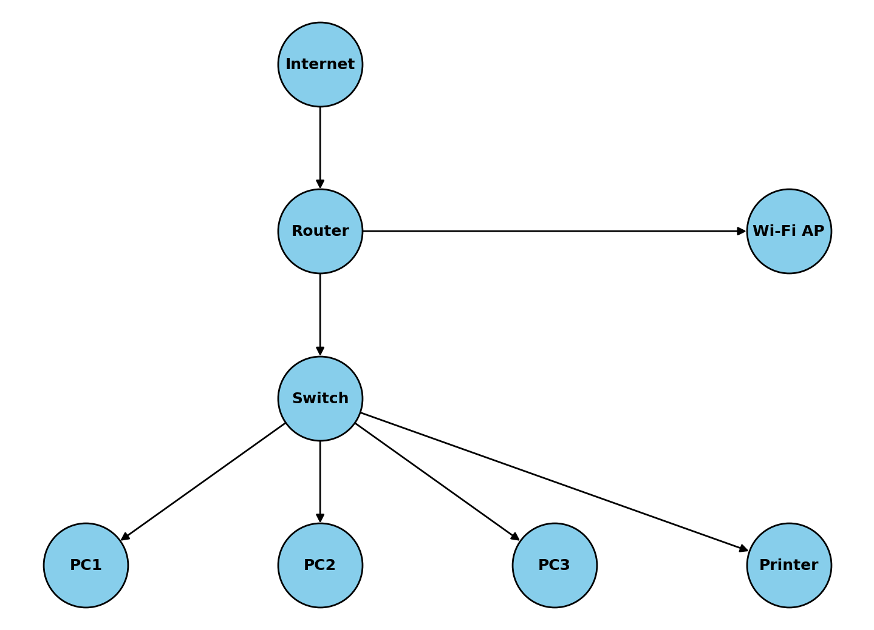

1. **List how many network devices and types of cable used and give its details.**

|  |  |  |
| --- | --- | --- |
| Device /Cable | Quantity | Details |
| Router | 1+ | Connects LAN to ISP/Internet, provides routing, NAT, and firewall |
| Switch | 2+ | Connects multiple PCs, servers, and printers in the LAN |
| Desktop PCs | 30+ | Used by students and staff for academic and administrative work. |
| Printer | 3+ | Network-enabled printer for lab and office use. |
| Ethernet (Cat -6) Cable | Several (approx.100m) | Used for wired connections between devices and switches. |
| Wi-fi Access Point | In each LAB’s | Provides wireless connectivity for laptops and mobile devices. |